|  |  |  |  |  |  |  |  |  |
| --- | --- | --- | --- | --- | --- | --- | --- | --- |
| **Activity** | **Start** | **End** | **Time** | **ES** | **EF** | **LF** | **LS** | **Slack** |
| **t7** | **0** | **3** | **3** | **0** | **8** | **8** | **0** | **0** |
| **t8** | **3** | **7** | **4** | **8** | **14** | **16** | **10** | **2** |
| **t9** | **0** | **2** | **2** | **0** | **4** | **10** | **6** | **6** |
| **t10** | **3** | **10** | **7** | **4** | **13** | **19** | **10** | **6** |
| **t11** | **7** | **17** | **10** | **8** | **19** | **19** | **8** | **0** |
| **t12** | **17** | **21** | **4** | **14** | **17** | **19** | **16** | **2** |
| **t13** | **4** | **21** | **7** | **19** | **20** | **20** | **19** | **0** |
| **t14** | **21** | **23** | **2** | **21** | **23** | **20** | **23** | **0** |

First task

Second task

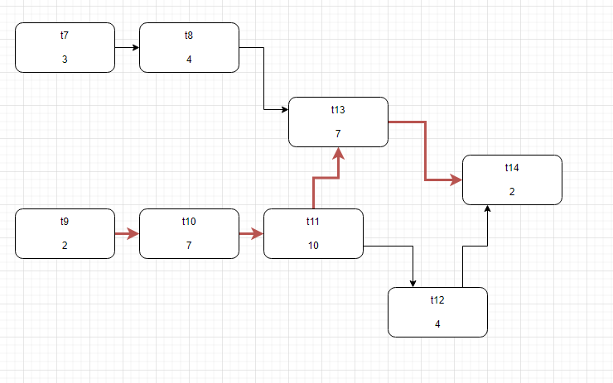

Answer is 26

Second task (b)

Second task (c)

First: t7 -> t8 -> t13 -> t14

Second: t9->t10->t11->t12